**Task 1: Explore the networks and instances**

Explore the instances and their connectivity

Let's try the same from **server-1**

* To test connectivity to server-2's external IP address

in put:

**student-03-2ab19081ed8c@server-2**:**~**$ ping -c 3 34.77.214.236

Out put:

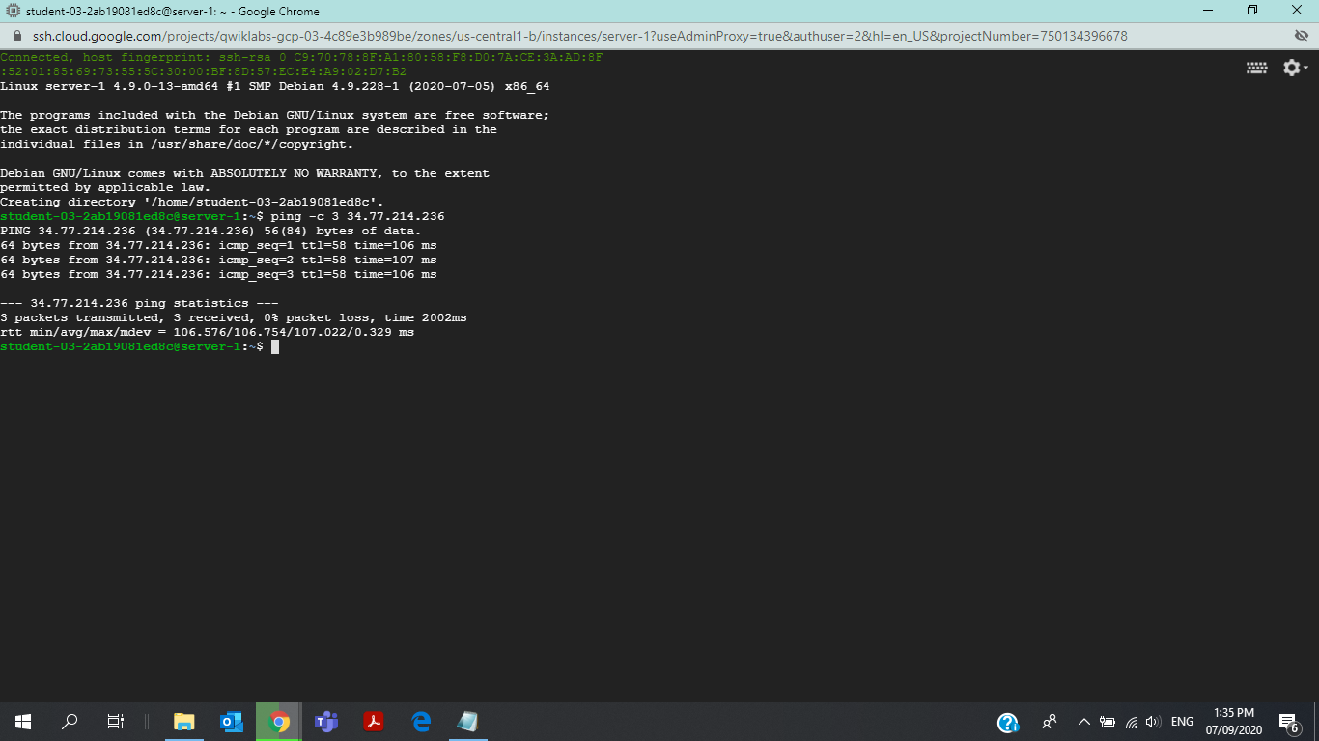

* To test connectivity to server-2's internal IP address

Input:

**student-03-2ab19081ed8c@server-2**:**~**$ ping -c 3 3 10.1.3.2

Output:

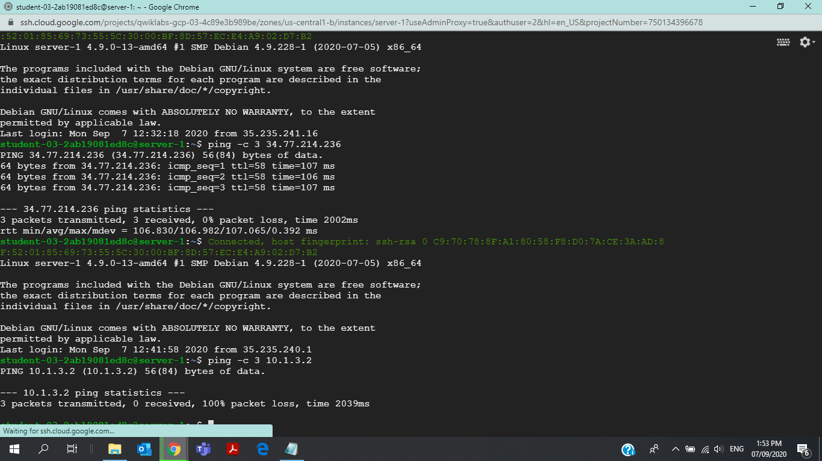

Let's try the same from **server-2**

* To test connectivity to server-1's external IP address

Input:

**student-03-2ab19081ed8c@server-2**:**~**$ ping -c 3 34.70.166.8

Input:

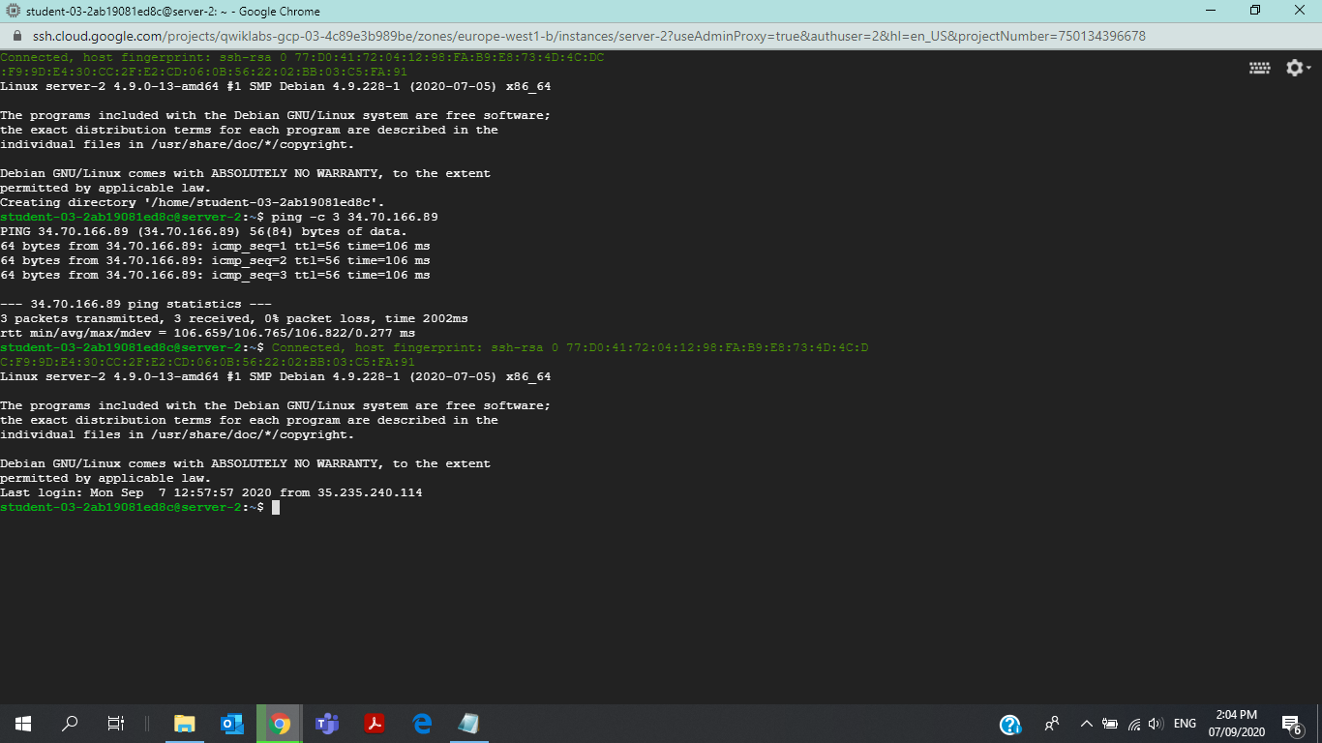

* To test connectivity to server-1's internal IP address

Input:

**student-03-2ab19081ed8c@server-2**:**~**$ ping -c 3 10.1.3.2

Output:

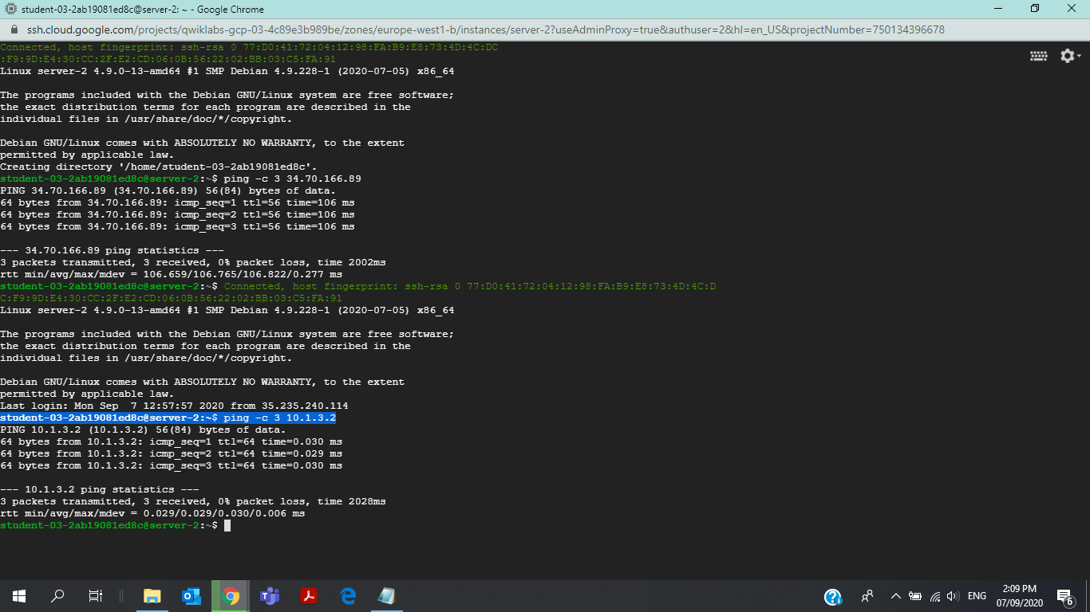



**Task 2: Create the VPN gateways and tunnels**

Input:

gcloud compute addresses create vpn-1-static-ip --project=qwiklabs-gcp-03-4c89e3b989be --region=us-central1

Output:

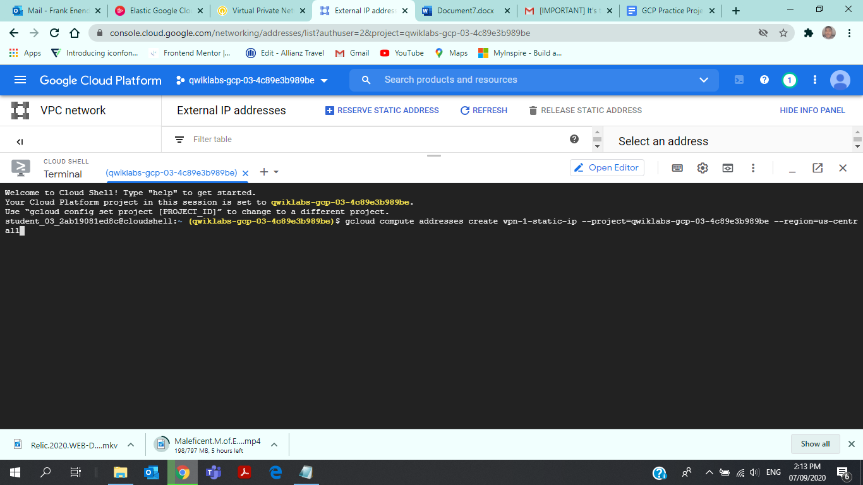

gcloud compute addresses create vpn-2-static-ip --project=qwiklabs-gcp-03-4c89e3b989be --region=europe-west1

* Create the vpn-1 gateway and tunnel1to2

Input:

gcloud compute --project "qwiklabs-gcp-02-29906a4683ff" target-vpn-gateways create "vpn-1" --region "us-central1" --network "vpn-network-1"

gcloud compute --project "qwiklabs-gcp-02-29906a4683ff" forwarding-rules create "vpn-1-rule-esp" --region "us-central1" --address "34.122.214.108" --ip-protocol "ESP" --target-vpn-gateway "vpn-1"

gcloud compute --project "qwiklabs-gcp-02-29906a4683ff" forwarding-rules create "vpn-1-rule-udp500" --region "us-central1" --address "34.122.214.108" --ip-protocol "UDP" --ports "500" --target-vpn-gateway "vpn-1"

gcloud compute --project "qwiklabs-gcp-02-29906a4683ff" forwarding-rules create "vpn-1-rule-udp4500" --region "us-central1" --address "34.122.214.108" --ip-protocol "UDP" --ports "4500" --target-vpn-gateway "vpn-1"

gcloud compute --project "qwiklabs-gcp-02-29906a4683ff" vpn-tunnels create "tunnel1to2" --region "us-central1" --shared-secret "gcprocks" --ike-version "2" --local-traffic-selector "0.0.0.0/0" --target-vpn-gateway "vpn-1"

gcloud compute --project "qwiklabs-gcp-02-29906a4683ff" routes create "tunnel1to2-route-1" --network "vpn-network-1" --next-hop-vpn-tunnel "tunnel1to2" --next-hop-vpn-tunnel-region "us-central1" --destination-range "10.1.3.0/24"

Output:

* Create the vpn-2 gateway and tunnel2to1

Input:

gcloud compute --project "qwiklabs-gcp-02-29906a4683ff" target-vpn-gateways create "vpn-2" --region "europe-west1" --network "vpn-network-2"

gcloud compute --project "qwiklabs-gcp-02-29906a4683ff" forwarding-rules create "vpn-2-rule-esp" --region "europe-west1" --address "35.233.87.132" --ip-protocol "ESP" --target-vpn-gateway "vpn-2"

gcloud compute --project "qwiklabs-gcp-02-29906a4683ff" forwarding-rules create "vpn-2-rule-udp500" --region "europe-west1" --address "35.233.87.132" --ip-protocol "UDP" --ports "500" --target-vpn-gateway "vpn-2"

gcloud compute --project "qwiklabs-gcp-02-29906a4683ff" forwarding-rules create "vpn-2-rule-udp4500" --region "europe-west1" --address "35.233.87.132" --ip-protocol "UDP" --ports "4500" --target-vpn-gateway "vpn-2"

gcloud compute --project "qwiklabs-gcp-02-29906a4683ff" vpn-tunnels create "tunnel2to1" --region "europe-west1" --peer-address "34.122.214.108" --shared-secret "gcprocks" --ike-version "2" --local-traffic-selector "0.0.0.0/0" --target-vpn-gateway "vpn-2"

gcloud compute --project "qwiklabs-gcp-02-29906a4683ff" routes create "tunnel2to1-route-1" --network "vpn-network-2" --next-hop-vpn-tunnel "tunnel2to1" --next-hop-vpn-tunnel-region "europe-west1" --destination-range "10.5.4.0/24"

* Verify server-1 to server-2 connectivity

To test connectivity to **server-2**'s internal IP address & To test connectivity to **server-1**'s internal IP address

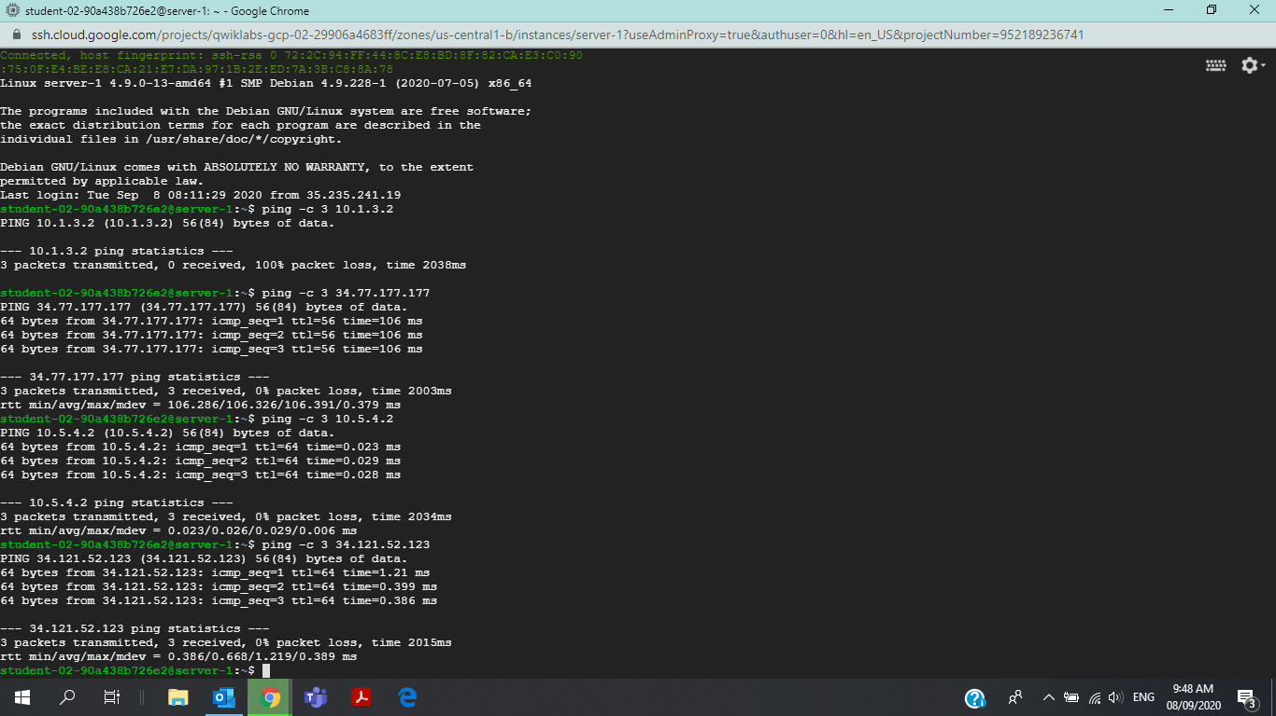

Remove the external IP addresses

Rest Comand

{ "cpuPlatform": "Unknown CPU Platform", "creationTimestamp": "2020-09-08T01:05:05.916-07:00", "deletionProtection": false, "disks": [ { "autoDelete": true, "boot": true, "deviceName": "server-1", "diskSizeGb": "10", "guestOsFeatures": [ { "type": "VIRTIO_SCSI_MULTIQUEUE" } ], "index": 0, "interface": "SCSI", "kind": "compute#attachedDisk", "licenses": [ "projects/debian-cloud/global/licenses/debian-9-stretch" ], "mode": "READ_WRITE", "source": "projects/qwiklabs-gcp-02-29906a4683ff/zones/us-central1-b/disks/server-1", "type": "PERSISTENT" } ], "displayDevice": { "enableDisplay": false }, "id": "5774178761049802176", "kind": "compute#instance", "labelFingerprint": "dyhvaKSGZZQ=", "labels": { "goog-dm": "qldm-18138544-69f5b6209afdc2d4" }, "machineType": "projects/qwiklabs-gcp-02-29906a4683ff/zones/us-central1-b/machineTypes/n1-standard-1", "metadata": { "fingerprint": "SOmBftF76ak=", "kind": "compute#metadata" }, "name": "server-1", "networkInterfaces": [ { "fingerprint": "z8-CDi2ADfo=", "kind": "compute#networkInterface", "name": "nic0", "network": "projects/qwiklabs-gcp-02-29906a4683ff/global/networks/vpn-network-1", "networkIP": "10.5.4.2", "subnetwork": "projects/qwiklabs-gcp-02-29906a4683ff/regions/us-central1/subnetworks/subnet-a" } ], "scheduling": { "automaticRestart": true, "onHostMaintenance": "MIGRATE", "preemptible": false }, "selfLink": "projects/qwiklabs-gcp-02-29906a4683ff/zones/us-central1-b/instances/server-1", "startRestricted": false, "status": "TERMINATED", "tags": { "fingerprint": "42WmSpB8rSM=" }, "zone": "projects/qwiklabs-gcp-02-29906a4683ff/zones/us-central1-b" }

Ou9